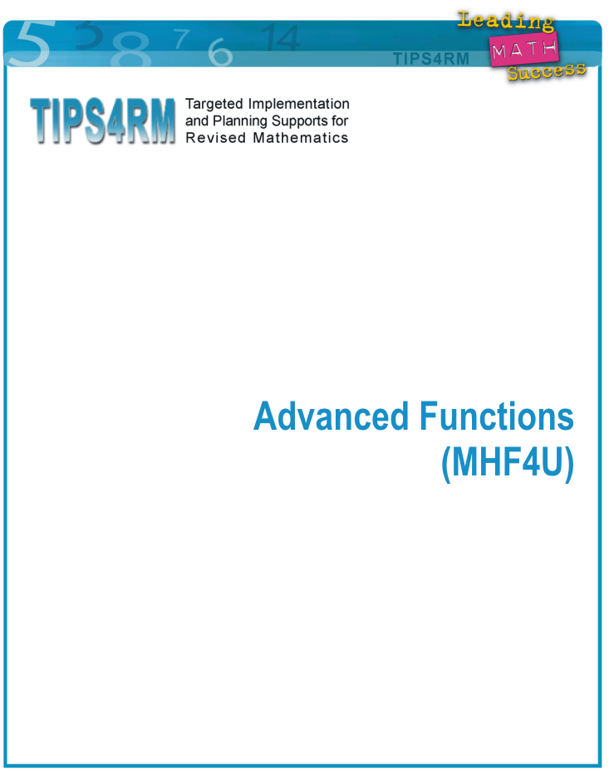

Advanced Functions: Content and Reporting Targets

Mathematical Processes across all strands: Problem Solving; Reasoning and Proving; Reflecting; Selecting Tools
and Computational Strategies; Connecting, Representing, and Communicating

Introductory Unit |  | Unit 1 | Unit 2
- Sketch graphs from descriptions of a set of properties, from a description of a scenario, using prior knowledge of:  - Function notation  - Vertical line test  - Key properties of functions:  - average rate of change  - instantaneous rate of change  - zeros  - y-intercept/initial condition  - domain and range  - Inverse functions  - Transformations of functions  - Difference tables |  | - Polynomial functions – Characteristics embed average and instantaneous rates of change  - Solving equations – embed intervals of increase/ decrease  - Transformations  - Explore end behaviours  - Embed inequalities | - Rational functions  - Embed average and instantaneous rates of change  - Solving equations  - Embed inequalities  - Explore behaviour around asymptotes
Unit 3 | Unit 4 | Unit 5 | Unit 6
- Radian measure and graphing primary and their reciprocal trigonometric functions (using key properties)  - Square scale  - Rate of change | - Trigonometric functions  - Solving equations  - Solving problems  - Identities  - Transformations | - Exponential and logarithmic functions  - Average and instantaneous rates of change  - Exponent laws/laws of logarithms  - Include non-natural number bases  - Solve exponential and logarithmic equations | - Consolidate characteristics of functions (compare and contrast)  - Composition of functions  - Compound functions  - Generalize functions

Rationale
Inclusion of the Introductory Unit:
- This Introductory Unit is not to be presented as a review unit. Rather, build conceptual understanding of general functions based on key concepts previously studied.
- Build a framework of key concepts that can be applied to all functions, e.g., average rate of change, intervals of increase/decrease, domain/range, zeros.

Embedding ‘average and instantaneous rates of change’ with each type of function:
- The different natures of the average and instantaneous rates of change of various types of functions can be appreciated more deeply by linking them function by function.
- A gradual building of this key concept allows re-visiting it as students’ thinking matures.

Splitting polynomial and rational functions into two units:
- The framework of key concepts developed in the Introductory Unit is applied to familiar polynomial functions.
- Concepts of average rate of change, and end behaviours can be established with polynomial functions without the added complexity of asymptotes.
- Polynomial and rational functions have different properties.
- Concepts of rational functions can be built on known properties of polynomial functions.

Positioning trigonometry after rational functions:
- The tangent and reciprocal functions are introduced as applications of concepts of rational functions.

Splitting trigonometry into two units:
- The initial focus is on introducing radian measure, and revisiting all of the Grade 11 concepts using radians, e.g., zeros, period, amplitude, domain/range, phase shift.
- Rates of change are connected to graphs and numerical representations in the first trigonometric unit to consolidate graphical properties.
- Some consolidation of basic trigonometric facts is needed before students are ready to pose and solve problems that can be modelled by these functions.

Using Unit 6 for consolidating and culminating:
- Allows for a consolidation of characteristics of functions to compare and contrast the various types of functions in this course;
- Uses the characteristics of functions as the basis for combining and composing functions;
- Concepts provide opportunities to generalize functions and properties of functions.

Advanced Functions – Planning Tool

P Number of pre-planned lessons (including instruction, diagnostic and formative assessments, summative assessments other than course performance tasks)
J Number of jazz days of time (instructional or assessment)
T Total number of days
CPT Course performance task

Unit | Cluster of  Curriculum Expectations | Overall Expectations | P | J | T
0 | - Revisit contexts studied in the Grade 11 Functions course (MCR3U) using simplifying assumptions, adding precision to the graphical models, and discussing key features of the graphs using prior academic language (e.g., domain, range, intervals of increase/decrease, intercepts, slope) and ‘local maximum/minimum,’ ‘overall maximum/minimum.’  - Recognize that transformations previously applied to quadratic and trigonometric functions also apply to linear and exponential functions, and to functions in general.  - Use function notation to generalize relationships between two functions that are transformations of each other and whose graphs are given.  - Represent key properties of functions graphically and using function notation.  - Form inverses of functions whose graphs are given, and apply the vertical line test to determine whether or not these inverses are functions. | C1 identify and describe some key features of polynomial (linear, quadratic, trigonometric, exponential)* functions, and make connections between the numeric, graphical, and algebraic representations of polynomial* functions  D1 demonstrate an understanding of average and instantaneous** rate of change, and determine, numerically and graphically, and interpret the average rate of change of a function over a given interval and the instantaneous rate of change of a function at a given point**  *reviews characteristics of functions already known  **to be addressed in Units 1, 2, 3, 4, 5, and 6 | 6 | 1 | 7
1 | - Identify and use key features of polynomial functions.  - Solve problems using a variety of tools and strategies related to polynomial functions.  - Determine and interpret average and instantaneous rates of change for polynomial functions. | C1 identify and describe some key features of polynomial functions, and make connections between the numeric, graphical, and algebraic representations of polynomial functions  C3 solve problems involving polynomial and simple rational* equations graphically and algebraically  C4 demonstrate an understanding of solving polynomial and simple rational inequalities*  D1 demonstrate an understanding of average and instantaneous rate of change, and determine, numerically and graphically, and interpret the average rate of change of a function over a given interval and the instantaneous rate of change of a function at a given point  *to be addressed in Unit 2 | 15 | 2 | 17
2 | - Identify and use key features of rational functions.  - Solve problems using a variety of tools and strategies related to rational functions.  - Determine and interpret average and instantaneous rates of change for rational functions. | C2 identify and describe some key features of the graphs of rational functions, and represent rational functions graphically  C3 solve problems involving polynomial* and simple rational equations graphically and algebraically  C4 demonstrate and understanding of solving polynomial* and simple rational inequalities  D1 demonstrate an understanding of average and instantaneous rate of change, and determine, numerically and graphically, and interpret the average rate of change of a function over a given interval and the instantaneous rate of change of a function at a given point  * addressed in Unit 1 | 6 | 1 | 7
3 | - Explore, define and use radian measure.  - Graph primary trigonometric functions and their reciprocals in radians and identify key features of the functions.  - Solve problems using a variety of tools and strategies related to trigonometric functions.  - Determine and interpret average and instantaneous rates of change for trigonometric functions. | B1 demonstrate an understanding of the meaning an application of radian measure  B2 make connections between trigonometric ratios and the graphical and algebraic representations of the corresponding trigonometric functions and between trigonometric functions and their reciprocals, and use these connections to solve problems  D1 demonstrate an understanding of average and instantaneous rate of change, and determine, numerically and graphically, and interpret the average rate of change of a function over a given interval and the instantaneous rate of change of a function at a given point | 9 | 1 | 10
4 | - Graph and transform sinusoidal functions using radian measure.  - Identify domain, range, phase shift, period, amplitude, and vertical shift of sinusoidal functions using radian measures.  - Develop equations of sinusoidal functions from graphs and descriptions expressed in radian measure.  - Solve problems graphically that can be modelled using sinusoidal functions.  - Prove trigonometric identities.  - Solve linear and quadratic trigonometric equations using radian measures.  - Make connections between graphic and algebraic representations of trigonometric relationships. | B2 make connections between trigonometric ratios and the graphical and algebraic representations of the corresponding trigonometric functions and between trigonometric functions and their reciprocals, and use these connections to solve problems  B3 solve problems involving trigonometric equations and prove trigonometric identities | 11 | 2 | 13
5 | - Develop the understanding that the logarithmic function is the inverse of the exponential function.  - Simplify exponential and logarithmic expressions using exponent rules.  - Identify features of the logarithmic function including rates of change.  - Transform logarithmic functions.  - Evaluate exponential and logarithmic expressions and equations.  - Solve problems that can be modelled using exponential or logarithmic functions. | A1 demonstrate an understanding of the relationship between exponential expressions and logarithmic expressions, evaluate logarithms, and apply the laws of logarithms to simplify numeric expressions  A2 identify and describe some key features of the graphs of logarithmic functions, make connections between the numeric, graphical, and algebraic representations of logarithmic functions, and solve related problems graphically  A3 solve problems involving exponential and logarithmic equations algebraically, including problems arising from real-world applications  D1 demonstrate an understanding of average and instantaneous rate of change, and determine, numerically and graphically, and interpret the average rate of change of a function over a given interval and the instantaneous rate of change of a function at a given point | 12 | 1 | 13
6 | - Consolidate understanding of characteristics of functions (polynomial, rational, trigonometric, and exponential).  - Create new functions by adding, subtracting, multiplying, or dividing functions.  - Create composite functions.  - Determine key properties of the new functions.  - Generalize their understanding of a function. | D1 demonstrate an understanding of average and instantaneous rate of change, and determine, numerically and graphically, and interpret the average rate of change of a function over a given interval and the instantaneous rate of change of a function at a given point  D2 determine functions that result from the addition, subtraction, multiplication, and division of two functions and from the composition of two functions, describe some properties of the resulting functions, and solve related problems  D3 compare the characteristics of functions, and solve problems by modelling and reasoning with functions, including problems with solutions that are not accessible by standard algebraic techniques | 13 | 1 | 14
CPT | Course Performance Task |  |  |  | 4
 | Total Days |  | 72 | 9 | 85

The number of prepared lessons represents the lessons that could be planned ahead based on the range of student readiness, interests, and learning profiles that can be expected in a class. The extra time available for “instructional jazz” can be taken a few minutes at a time within a pre-planned lesson or taken a whole class at a time, as informed by teachers’ observations of student needs.

The reference numbers are intended to indicate which lessons are planned to precede and follow each other. Actual day numbers for particular lessons and separations between terms will need to be adjusted by teachers.

Introductory Unit: Advanced Functions MHF4U

Lesson Outline

Big Picture

Students will:
- revisit contexts studied in the Grade 11 Functions course (MCR3U) using simplifying assumptions, adding precision to the graphical models, and discussing key features of the graphs using prior academic language (e.g., domain, range, intervals of increase/decrease, intercepts, slope) and ‘local maximum/minimum,’ ‘overall maximum/minimum;’
- recognize that transformations previously applied to quadratic and trigonometric functions also apply to linear and exponential functions, and to functions in general;
- use function notation to generalize relationships between two functions that are transformations of each other and whose graphs are given;
- represent key properties of functions graphically and using function notation;
- form inverses of functions whose graphs are given, and apply the vertical line test to determine whether or not these inverses are functions.
Day | Lesson Title | Math Learning Goals | Expectations
1–2 | Adding Precision to Graphical Models and Their Descriptions  (lessons not included) | - From initial simplifying assumptions about a context and the corresponding distance/time graph, introduce the complicating factors in the context and analyse adjustments needed in the graph e.g., swimming laps in a pool; riding a bicycle up a hill, down a hill, or on the flat.  - Use the following academic language to describe changes: speed (rate of change), intervals of increase/decrease, domain/range, overall and local maximum, and overall and local minimum.  - Graph corresponding speed/time graphs. | D1.1, D3.1, and setting up C1.2
3 | Transformations Across Function Types  (lesson not  included) | - Use function notation to generalize relationships between sets of two congruent functions, e.g., to generalize a line and the line shifted 2 units, a parabola and the parabola shifted 2 units up, an exponential function and the exponential function shifted 2 unit up;  - Use graphical and numerical representations of the functions.  - Introduce the concept that lines and exponential functions can be seen through a transformational lens.  - Graphfrom any given | Setting up C1.6, A2.3
4 | Using Function Notation to Generalize Relationships  (lesson not  included) | - Use function notation to generalize relationships between sets of two functions, one a single transformation of the other e.g.,to generalize a sinusoidal function and the stretched sinusoidal function, a line and the stretched line, a parabola and the stretched parabola, an exponential function and the stretched exponential function shifted 2 units up;  - Use graphical and numerical representations of the functions. | Setting up C1.6
Day | Lesson Title | Math Learning Goals | Expectations
5 | Representing Key Properties of Functions Graphically and Using Function Notation  (lesson not included) | - Interpret graphically, values shown in function notation, e.g., Graphthat has all of the following properties: forand fordomainrange  - Explore multiple solutions to each of the above, noting the lack of information for determining concavity.  - Represent critical points and key regions of the graph of a function using functional notation. | Setting up C1.7, 2.2, A2.1
6 | Forming Inverses and Function Testing  (lesson not included) | - Form inverses of given functions (graphical representations) and determine whether or not the inverse is a function. | Setting up A1.1, 2.2
7 | Jazz Day to summarize

